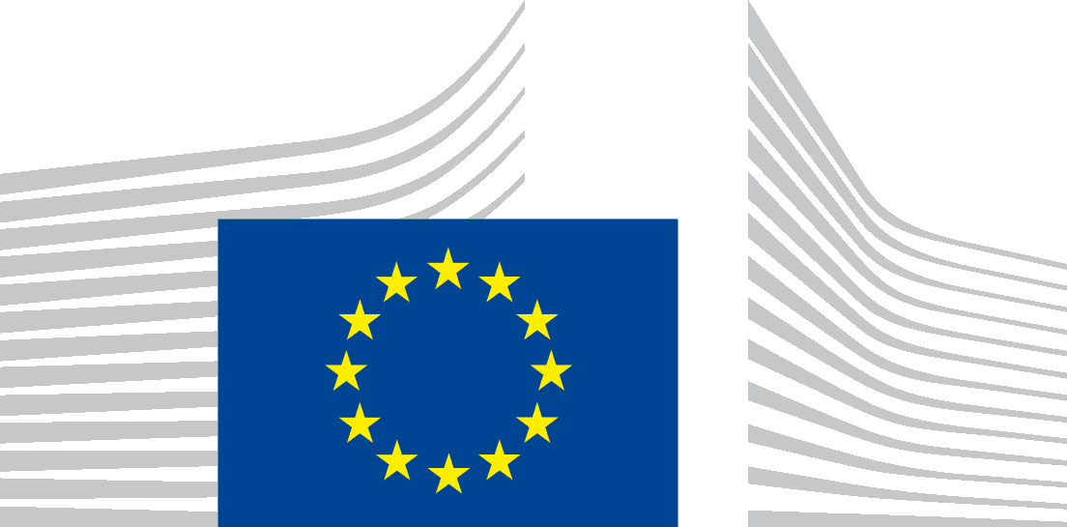 | EUROPÄISCHE KOMMISSION  GENERALDIREKTION FÜR STEUERN UND ZOLLUNION  Indirekte Steuern und Steuerverwaltung  Kontrolle der Anwendung des EU-Rechts und staatlichen Beihilfen / indirekte Steuern
Brüssel, den
TAXUD C3 (2014) 1234
BSK/og – DE/2014/CHAP00000/reply
Official in charge:
Claire Grube: 00.32.2.291.23.45
Herr Alexander Platz
E-mail: alexanderplatz @dschimail.com

A traduire en allemand

CHAP/14/00127 – Österreich – Glücksspielabgabe und Glücksspielautomaten
Ihre Anfrage vom 8. Januar 2014

Sehr geehrter Herr Platz,
I refer to your above mentioned letter. In your letter you raise the question which measures could be taken with regard to the different rates of the Glücksspielabgabe applied in Austria.
You explain that the tax has to be paid by publically recognised entities and by private operators. The provisions laid down in the Glücksspielgesetz deem the taxable event to be the supply of services for consideration, namely in the use of slot machines. The Austrian laws fix the rate of the levy at a percentage of the price, that is to say, the price actually paid by the consumer net of taxes. The rate applicable to services supplied by publically recognised entities is lower than the rate applicable to the same services provided by the private sector.
First, I have to underline that the tax law in the European Union is only partly harmonised. Due to this fact, the Member States are allowed to introduce any tax or fees outside of the harmonised taxes. This means that Member States may impose these taxes and decide unilaterally upon their levels and methods of calculation provided they respect the Treaties, that give them fairly wide space for their own specific tax legislation. This is also the case of the Austrian Glücksspielabgabe. Such taxes are levied also in other Member States of the European Union.
In other words, there is no EU law, which would require Austria to eliminate the tax in question or which would regulate the level of this levy.
In its Judgment on the Joined Cases C-453/02 and C-462/02 Linneweber and Akritidis, the Court of Justice of the EU gave an interpretation of Article 13B(f) of the Sixth VAT Directive. The Court of Justice ruled that that provision precludes national legislation which provides that the operation of all games of chance and gaming machines is exempt from tax where it is carried out in licensed public casinos, while the operation of the same activity by traders other than those running casinos does not enjoy that tax exemption; an operator of gaming machines can rely directly on that provision before national courts to prevent the application of rules of national law which are inconsistent therewith.
Those Cases concerned the VAT treatment of the services at stake under the German VAT legislation. The rules on VAT are harmonised in the European Union and to be found in the current VAT Directive. This means that Member States are obliged to implement the system and principles laid down in that directive.
The force of the VAT Directive is increased by the interpretation given by the Court's rulings. The above mentioned judgment refers to the EU VAT law and its interpretation. As the reasons and verdict of the decision concern VAT, the judgment's statements cannot not be converted at another non harmonised levy, such as the Glücksspielabgabe. Indeed, that charge does not fall within the scope of that ruling.
In the light of above and according to the available information, there are no reasons to believe that the Austrian system of assessing and collecting the Glücksspielabgabe does not comply with the requirements imposed by EU law on tax issues.
If you are of the opinion that the domestic law on the Glücksspielabgabe does not comply with the rules in the area of European Competition law you may file a complaint (including the necessary information) to the European Commission. You will find appropriate details under the following internet address:
http://ec.europa.eu/eu_law/your_rights/your_rights_forms_de.htm
I hope this information has been useful to you.
Mit freundlichen Grüßen

Gitta Stäbe
Referatsleiterin

Sixth Council Directive 77/388/EEC of 17 May 1977 on the harmonization of the laws of the Member States relating to turnover taxes - Common system of value added tax: uniform basis of assessment, OJ L 145, 13.6.1977, p. 1–40
Council Directive 2006/112/EC of 28 November 2006 on the common system of value added tax, OJ L 347 of 11.12.2006.

