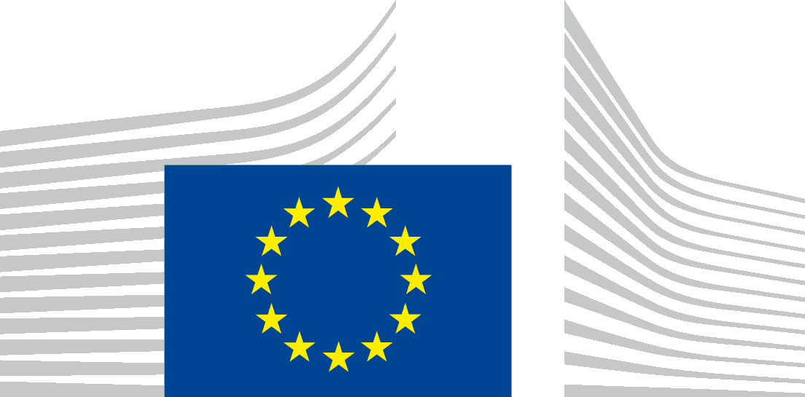 | EUROPEAN COMMISSION  DIRECTORATE-GENERAL  TAXATION AND CUSTOMS UNION  Indirect Taxation and Tax administration  VAT and other turnover taxes
Group on the Future of VAT
8th meeting – 12 June 2013
taxud.c.1(2013)1140578 – EN
Brussels, 8 May 2013

Group on the Future of VAT

GFV Nº 029

Outcome of the public consultation on VAT rates

Introduction
The review of the current VAT rates structure was one of the priority actions put forward in the Communication on the future of VAT presented by the Commission on 6 December 2011. The Commission also specified that this review should be based on the following guiding principles:
- Abolition of those reduced rates which constitute an obstacle to the proper functioning of the internal market. Reduced rates that were justified in the past can have distortive effects today because the economic, business and legal environments have changed in the meantime;
- Abolition of reduced rates on goods and services whose consumption is discouraged by other EU policies. This could notably be the case for goods and services harmful to the environment, health and welfare;
- Similar goods and services should be subject to the same VAT rate and progress in technology should be taken into account in this respect, so that the challenge of convergence between the on-line and the physical environment is addressed.

Public consultation on reduced VAT rates
The Commission services made a first evaluation of the current VAT rates structure in the light of the abovementioned guiding principles.
This formed the basis of the consultation paper that was used for the public consultation which was launched on 8 October 2012. This public consultation was very targeted since it took place within the strict framework of the three above-mentioned guiding principles. Stakeholders were therefore invited to reply to 9 specific questions which were directly related to those guiding principles.
The consultation was closed on 4 January 2013 and a total of 333 contributions were received.
The consultation paper, the summary report of the outcome of the public consultation and the responses are available at
http://ec.europa.eu/taxation_customs/common/consultations/tax/2012_vat_rates_en.htm

Questions to the delegates
The delegates are invited to comment upon the outcome of the public consultation.
In particular, delegates are invited to express their views on the outcome of the public consultation as regards:
- Abolition of those reduced rates which constitute an obstacle to the proper functioning of the internal market (Question 1);
- Abolition of reduced rates on goods and services whose consumption is discouraged by other EU policies (Questions 2 to 5);
- Similar goods and services should be subject to the same VAT rate (Questions 6 to 9).

***

