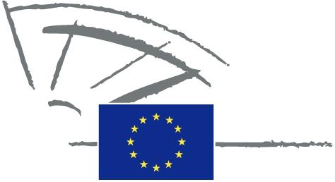
 | EUROPEAN PARLIAMENT | 2014 - 2019

<Commission>{PETI}Committee on Petitions</Commission>

<Date>{30/04/2014}30.4.2014</Date>
<TitreType>NOTICE TO MEMBERS</TitreType>
Subject: <TITRE>Petition 0969/2013 by Karl Brutscher and Norbert Laube (German), on non-compliance with the Alpine Convention in Germany</TITRE>
1. Summary of petition
The petitioners point out that protected natural areas, such as Egartenlandschaft um Miesbach and Tegernsee und Umgebung in Bavaria, are gradually getting smaller due to building activities. They maintain that although the implementation protocols for the Alpine Convention were already legally binding in Germany in 2002, they still have not been implemented. The current rules stipulate that protected areas must not be reduced and no building work of any kind may be carried out which will have a significant impact on the landscape. The petitioners mention a number of examples of building works which are nevertheless being prepared or implemented and have had building permits issued by the competent authorities. They use expert publications to clarify the way in which the provisions of the Alpine Convention must be interpreted and indicate that they are binding. The petitioners believe that reducing the size of the natural areas by allocating building sites is contrary to the Alpine Convention’s provisions. They are requesting the European Parliament to investigate this matter and call on Germany to halt these violations of the Alpine Convention and possible other natural protection regulations.
2. Admissibility
Declared admissible on 11 February 2014. Information requested from Commission under Rule 202(6).
3. Commission reply, received on 30 April 2014
According to available information, a complaint similar to this petition was already considered on its merits and rejected by the Bavarian Constitutional Court in its decision of 13 September 2012.
The petition essentially concerns the question of interpretation of Article 11(1) of the Protocol, i.e. whether it prohibits reducing the size of protected areas designated by the Parties to the Protocol. The protected areas in question are landscape protection areas designated under the German law.
The European Union is not a Party to the Protocol and therefore the Protocol is not part of EU rules. Also the protected areas in question are designated, and their protection status is defined, under German national law alone, not under EU legislation.
Consequently, the subject matter of this petition does not fall within the scope of EU rules. It is therefore not for EU institutions, but for the Parties to the Protocol to interpret provisions of the Protocol.
Under this Convention, a compliance committee has been set up with the task to oversee the implementation of the Convention and its Protocols and is competent to investigate individual cases of supposed non-compliance. The complaints can be submitted to the Committee through Contracting Parties and Observers. By means of example, recently a non-governmental organisation who is an observer to the Convention, has submitted two cases of alleged non-compliance.
Conclusions
The subject matter of the petitions falls outside of the scope of EU rules. We advise petitioners to turn to the competent body for the implementation of the Alpine Convention and its Protocols, i.e. compliance committee, through appropriate channels, including non-governmental organisations that are observers to the Convention, if they believe a Contracting Party has breached these agreements.

http://www.bayern.verfassungsgerichtshof.de/16-VII-11-Entscheidung.htm.

