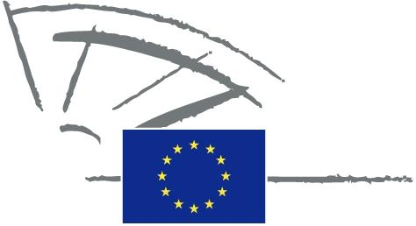
 | EUROPEAN PARLIAMENT | 2009 - 2014

<Commission>{PETI}Committee on Petitions</Commission>

<Date>{31/03/2014}31.3.2014</Date>
<TitreType>NOTICE TO MEMBERS</TitreType>
Subject: <TITRE>Petition 0894/2013 by Andreas M. Walter (German) on the transmission of German public television channels via the media company Belgacom in Belgium </TITRE>
1. Summary of petition
The petitioner discovered, to his surprise and incomprehension, that from 14 May 2013, he could no longer receive the German public broadcasting channels ARD and ZDF from the Belgian media company Belgacom, as part of the channel offering for Brussels. After enquiring about this, the petitioner learnt that Belgacom and the two German channels could not agree on broadcasting terms. The petitioner believes that it is of paramount importance in Belgium, and definitely in Brussels, as the capital of Europe, to have high-quality, reliable and pluralistic news coverage in all languages. Information from and about Germany is very important to policy makers in the European institutions. According to the petitioner, media diversity, pluralism and open debate based on reliable information are the basic conditions for a democratic society and European integration. There is good reason why these are enshrined in many constitutions and in the EU’s Charter of Fundamental Rights. The petitioner calls for the European Parliament to take action so that the negotiations are resumed between Belgacom and the German broadcasters. He believes that this is particularly important now with the upsurge in national prejudices and with there being increasingly less information available about the ‘others’.
2. Admissibility
Declared admissible on 20 January 2014. Information requested from Commission under Rule 202(6).
3. Commission reply, received on 31 March 2014
The Commission aims to ensure the respect of rights and principles enshrined in the Charter of Fundamental Rights of the EU, including Article 11 on freedom of expression and information (encompassing media freedom and pluralism) within its competences. In view of this, the Audiovisual Media Services Directive (2010/13/EU) introduces rules to promote a strong, competitive and integrated European audiovisual industry and to enhance media pluralism throughout the Union. At the same time, subject to EU competition law, the service operators and right holders are free to decide about the conclusion of licensing agreements and about the coverage of specific territories.
In 2010, the European Commission has committed in the Digital Agenda for Europe to facilitate the cross-border availability of creative content by giving incentives to operators to engage in content distribution across the EU (http://ec.europa.eu/information_society/digital-agenda/index_en.htm).
In 2013, the European Commission organised a stakeholder dialogue to address in particular cross-border portability of content and access to audiovisual works. One of the results of this dialogue is in particular the intention of certain stakeholders in the audiovisual sectors to facilitate the portability of audiovisual content across borders (http://ec.europa.eu/internal_market/copyright/licensing-europe/index_en.htm). In addition, the Commission launched end of 2013 a public consultation on the copyright framework, particularly regarding the availability of creative content within the Single Market. The participation at this consultation is notably open to citizens (deadline 5 March 2014): http://ec.europa.eu/internal_market/consultations/2013/copyright-rules/index_en.htm
Conclusion
The European Commission will review its copyright framework in light of the responses to public consultations. At the same time, it cannot in principle intervene in contractual arrangements of private companies.

