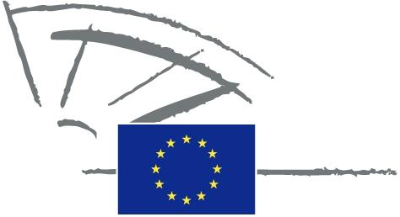
 | EUROPEAN PARLIAMENT | 2009 - 2014

<Commission>{PETI}Committee on Petitions</Commission>

<Date>{31/03/2014}31.3.2014</Date>
<TitreType>NOTICE TO MEMBERS</TitreType>
Subject: <TITRE>Petition 0646/2013 by H.H. (German) concerning free-of-charge satellite reception of the ORF Austrian national broadcasting channel</TITRE>
1. Summary of petition
The petitioner objects to what she regards as discrimination regarding reception of encoded ORF satellite broadcasts receivable only on payment of a fee to the Austrian authorities, which is not the case regarding the corresponding German channels. The petitioner calls for all European citizens to be given free access to their national television programmes.
2. Admissibility
Declared admissible on 2 December 2013. Information requested from Commission under Rule 202(6).
3. Commission reply, received on 31 March 2014
Typically, restrictions for access to creative content such as TV programmes result from licensing agreements between the service operators (e.g. broadcasters) and the respective right holders. Subject to EU competition law, the service operators and right holders are free to limit their licensing agreements to specific territories. Austrian public service broadcasters may therefore conclude agreements limiting their broadcasts to a specific territory and to enforce this restriction by using smart cards.
The European Commission has committed in the Digital Agenda for Europe to facilitate the cross-border availability of creative content by giving incentives to operators to engage in content distribution across the EU
(http://ec.europa.eu/information_society/digital-agenda/index_en.htm).
It should be noted that the financing and the remit of public service broadcaster lies within the competences of the Member States. According to Protocol N° 29 to the Treaty on the Functioning of the European Union, the provisions of the Treaty shall be without prejudice to the competence of Member States to provide for the funding of public service broadcasting insofar as such funding is granted to broadcasting organisations for the fulfilment of the public service remit as conferred, defined and organised by each Member State, and insofar as such funding does not affect trading conditions and competition in the Union to an extent which would be contrary to the common interest, while the realisation of the remit of that public service shall be taken into account.
Therefore, it is up to each Member State to fund its public service broadcasting and in this specific case the funding of the Austrian public service broadcasters could be based e.g. on territorial restrictions, insofar as this funding is granted for the fulfilment of the public service remit as defined by Austria.
Conclusion
The European Commission can help improving the cross border access to content on the long term, in the framework of the EU Strategy on Digital Agenda for Europe. However, it can in principle neither intervene in contractual arrangements nor modify the schemes Member States chose to finance their public service broadcasting.

